MAPPING:

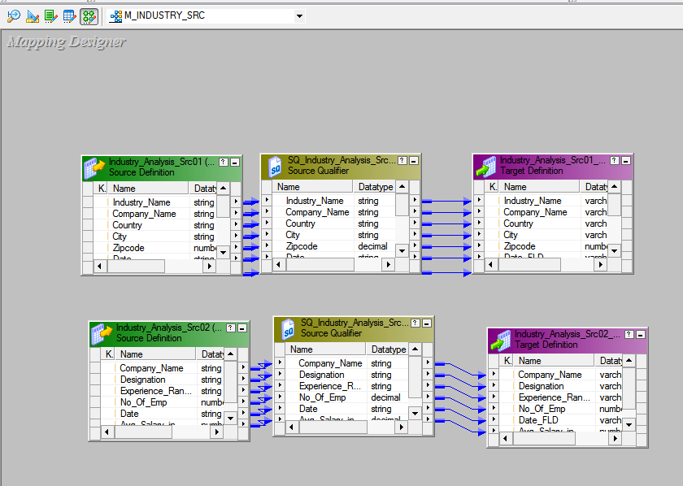

**TARGET OUTPUT:**

**FACT_AVG_SAL**

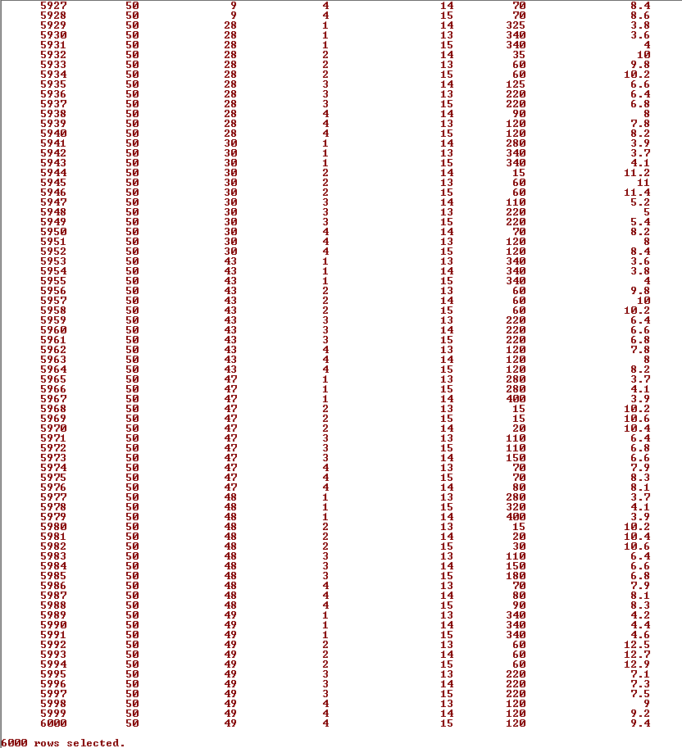

FACT_INDUSTRY_ANALYSIS:

